CSA1708-ARTIFICIAL INTELLIGENCE
LAB EXPERIMENTS

Program 2: write the python program to solve 8.queen problem.
Aim:
To write a Python program to solve the 8-Queens problem using the Backtracking
Algorithm:
- Start the program.
- Place one queen in each row.
- Check whether the position is safe.
- If safe, place the queen and move to the next row.
- If no safe position is found, backtrack to the previous row.
- Repeat until all 8 queens are placed.
- Display the solution.
- Stop.

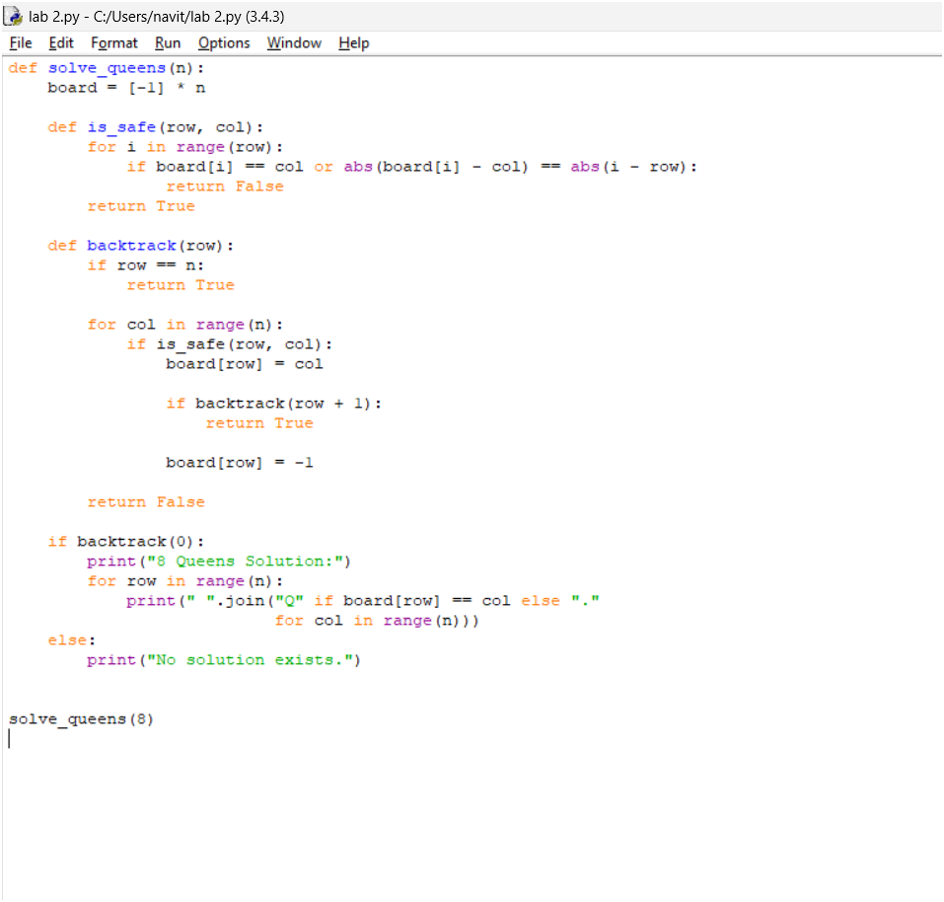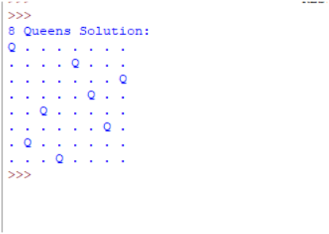
Result:
Thus, the 8-Queens problem was successfully solved using Python, and a valid arrangement of 8 queens was obtained.

